B4: Reference material
Terminology: legislation, policies and management plans
PURPOSE
The terms legislation/law/policies/regulations and rules/plans of often confused when talking about EAFM planning. This document provides some simple definitions that will help you ensure that everybody is talking about the same things.
HOW TO USE THIS DOCUMENT
The terms are used in several other documents and forms the basis for two activities in the 1-day LEAD High-level Consultation.
DEFINITIONS
Legislation
"Legislation" refers, in general terms, to the laws, regulations, decrees and other officially announced documents that provide the rules that governs the limits and obligations of people and institutions in order to provide the basis for a well-functioning society. “Legislation” in many countries refers to the Acts or Statutes that are enacted (approved/signed) by parliament. Because it takes a long time to get reach final approval (and to enter into force) laws and regulations should, ideally, be more general and written in a way that enable the development of supporting subordinate rules and regulations, sub-decrees and defined management actions and directives guiding compliance (see below), rather than containing specific management actions – and specific institutional responsibilities.
Rules and regulations
Often referred to as subordinate or subsidiary legislation, where a Minister or Ministry is given a mandate to issue rules and regulations on how the laws are to be implemented. Sector specific rules and regulations set out the specific details of management actions e.g. licensing to fish (usually part of the mandate of the Department of Fisheries) and fishing vessel registration (which is often the mandate of departments related to transport and shipping) as well as other specific requirements, such as banned gears, mesh size limitations, seasonal closures etc
Gazette
A kind of newsletter through which the government can “post” formal notification of the laws and regulations that has been issued together with the date of entry into force.
Notification
Notification 1: Formal notification by the issuing authority on rules and regulations including information on date of entry into force. Could be part of requirements to ensure proper registrations and licenses to undertake specific activities (such as fishing).
Notification 2: A requirement to inform the public and/or parties to an agreement on planned activities including major (infrastructure) projects
Policies
A statement of intent by an entity (e.g. government or business) to guide future actions and decision making that address a particular issue. In some countries policies are implemented through legislation, while in others legislation includes the policies.
Management plans
Management plans are specific plans that defines how a policy is to be implemented and is an important tool for turning policy into action. A good management plan only addresses key issues and their causes. It normally contains objectives, management actions/measures and ways to monitor and evaluate whether the plan is achieving its objectives over time. As with laws, the management plan should be generic with the actual specifics of management actions/measures contained in the rules and regulations (e.g. specific closure locations and times, specific mesh sizes etc).

Compliance and enforcement

Agreed fishery policies, rules and regulations and plans need to be followed by people (complied with) to be effective. Ensuring compliance is often carried out through a combination of Monitoring, Control and Surveillance (MCS) and enforcement activities.
The components of MCS include (note: the FAO definition of MCS does not include enforcement and this important element needs to be defined separately).
- Monitoring – the collection and analysis of information on fishing activities that relate to management and illegal activities;
- Control – the rules by which the fishery is managed; and
- Surveillance – the degree and types of observations required to detect illegal activities.

Enforcement activities range from “bottom up” activities such as self-regulation to “top down” activities such as arrests and penalties. Note that institutional responsibilities for monitoring, control and surveillance, respectively, are often mandated to a broad range of institutions, which requires a high degree of cooperation and coordination, while the mandate of “enforcement” might rest with, or rely on the involvement of the navy, coast guard or other entity with special powers.

Participation in the development of controls, as well as peer pressure, can lead to people comply with the fisheries management controls without the need for heavy “top down” enforcement measures.

Monitoring, Control and Surveillance (MCS) plans
Detailed plans that specifies what type of M, C, S and enforcement activities that are going to be carried out and by whom (what agency, institution or public/private actor). To be effective the MCS plans should emphasize the necessity of inter-agency and regional/sub-regional cooperation and coordination mechanisms (form the basis for the development of MCS-networks).
Plans to combat IUU fishing (e.g. National plan of action for IUU (NPOA-IUU)
IUU is an acronym for Illegal, Unreported and Unregulated fishing. The activities of illegal, unreported and unregulated fisheries activities as defined in the FAO International Plan of Action (IPOA-IUU) covers both national EEZs and the EEZs of other countries, as well as the high seas. A plan to combat IUU sets out what activities a country (State) intends to carry out to combat and reduce IUU fishing. To be effective plans to combat IUU fishing needs to be combined with improved national fisheries plans and national plans to manage fishing capacity (NPOA-Capacity) including sub-regional cooperation on the management of fishing capacity.
Legislation, policy and management plans framework
The diagram on the next page/below shows the connectivity of possible EAFM related legislation, policies and planning frameworks for a country at the national level. On the left-hand side is the legislation (using three components of the ecosystem approach in this example) and the linking Rules and Regulations. On the right-hand side are the overarching policies, which in turn link to a nested set of plans consisting of an EAFM Plan (that includes fisheries, environmental and human components, as well as governance), a specific environmental protection plan (MPA plan, refugia or conservation plans) and a poverty reduction plan.

Diagram of a possible national framework of legislation, policies and management plans.
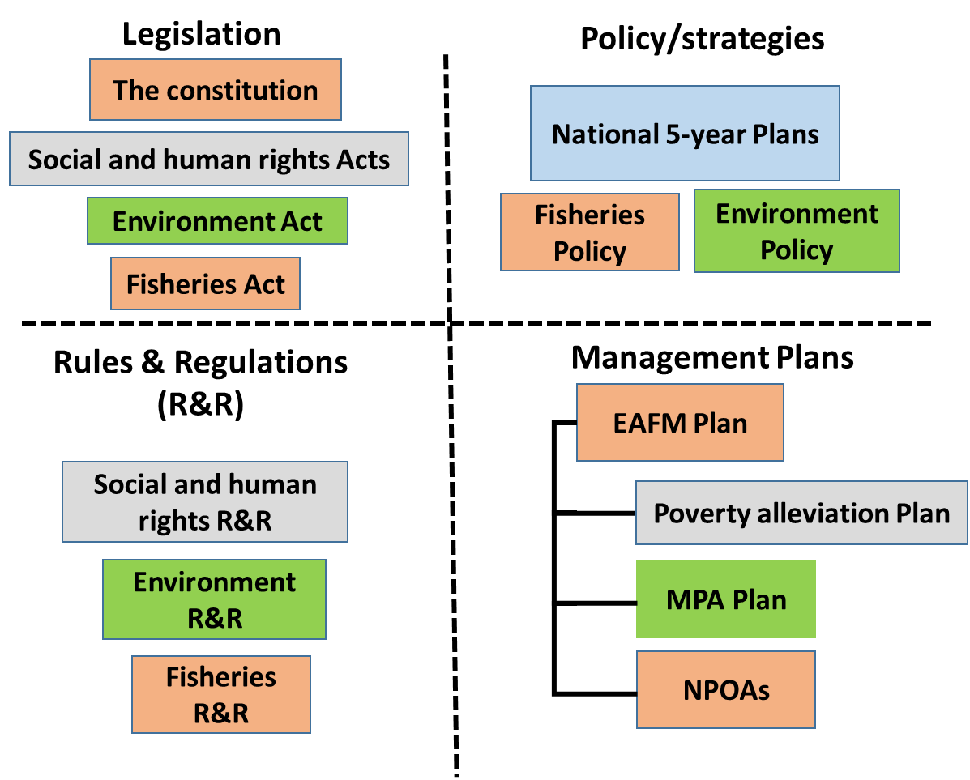

Superimposed on this framework are the levels of government and administration with some examples of the types of legislation, policies and levels that may be available at each level.
The geographic dimension (examples given as dot points).
Global
    - Legal instruments and agreements/ IPOAs
Regional
    - ASEAN Blueprints and SPAs/ SEAFDEC R&POA/ RPOA-IUU
National
    - National Constitutions
    - 5-year national social and economic development plans/ Fisheries Act/
    - National Fisheries Management Policy
Provincial
    - Policies and plans
District
    - Plans, traditional law and informal rules and regulations
Fisheries often cut across existing geographical jurisdiction as do environmental concerns. At the larger scale fisheries may be transboundary and involve two or more countries in its management. At the national level, fisheries often straddle two or more provinces and/or districts and require cooperation and coordination of rules and regulations as well as in developing networks for MCS and enforcement.

